Recommender System:

Individual Assignment 2 

*Hans Alberto Franke,* [*h.a.franke@students.uu.nl*](mailto:h.a.franke@students.uu.nl)

Personalization for Public Media

Applied Data Science - Utrecht University - 2021

**Main Objective**

Build a recommender system and interface taking in account user’s values like control, diversity, transparency and acceptance

# Introduction

Recommender systems have been researched extensively over the past decades. Whereas several algorithms have been developed and deployed in various application domains, recent research efforts are increasingly oriented towards the user experience of recommender systems [1]. This research goes beyond accuracy of recommendation algorithms and focuses on various human factors that affect acceptance of recommendations, such as user satisfaction, trust, transparency and sense of control.

Many different stakeholders can use or affect a recommender system. These stakeholder have different values and desired outcomes. Which leads to the question: How this can be connected and addressed in a single recommender system? How the interface can be used to answer for human values like **control**, **diversity**, **transparency** and **acceptance** and increase audience metrics like **usage** and **engagement**?

In this work, we present an interface that bridges the recommendation with visualization techniques to support human-recommender interaction.

# Methodology

Some well know values in literature are*,* **Transparency**thatdeals with the “black-box” nature of current recommender systems by explaining the inner logic of the system to end users. **Justification**helps users understand why they get certain recommendations, but it may not relate to the inner logic of the recommendation techniques. **Controllability**strengthens user involvement by incorporating input and feedback from the end user into the recommendation process. It can occurs in any step, such as providing ratings, adjusting preference data, and revising or exploring recommendations.

**Diversity***,* itrefers to providing recommendations with a relatively large coverage of the recommendation space [6]. For instance, it is important to recommend items that the user would prefer, but that are different from those which she has already purchased or experienced. The inability to make recommendation to new comers is called the **cold start**problem. Acquiring **contextual**information and incorporating it into recommendation processes in a flexible and fluid manner has gained increased interest over the past decades. The goal is to tailor recommendations to the current needs of the target user.

There is many ways to asses these values, and the **Algorithmic Affordance pattern library** is a first attempt to give an overview over the possibilities for designers to give end-users more control over the outcomes of algorithms [7]. These patterns can show many different possibilities to allow, measure and improve recommender system with well-designed interfaces (see table1).

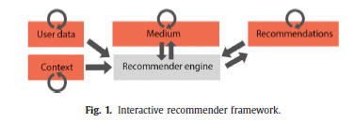

**Figure1**. Workflow of feedback from interaction of a **user** with **recommender.** Adapted from [8]

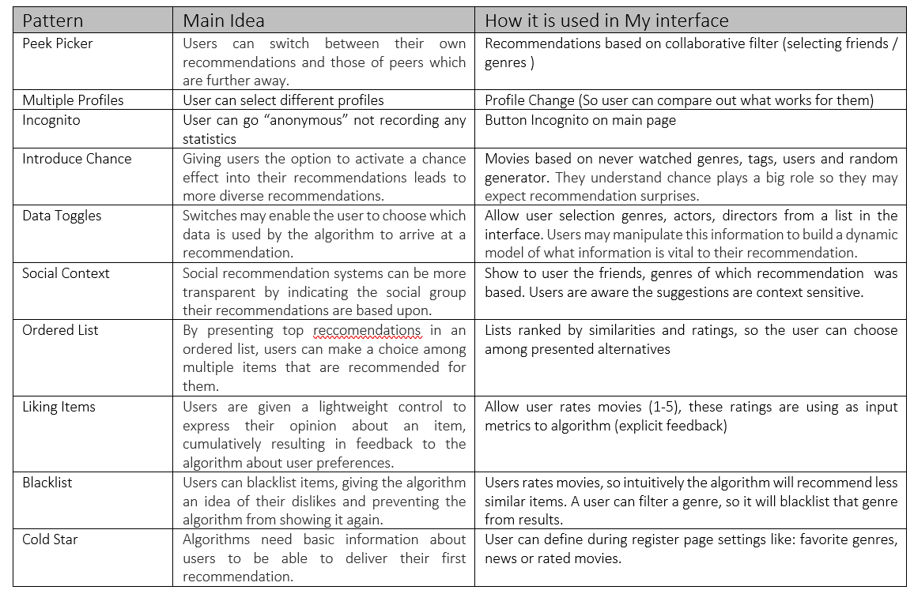

**Table1**. Summary of patterns used in this work with connection how they are assessed on the interface

# Recommender System and User’s Interface

## 3.1 How the interface allow personas/users values be assessed / Control:

Users can and should provide feedback through interface. The interface was designed focusing on assessing the main values: **Controllability***,* **Transparency**, **justify**and**Diversity***.* It was designed following the patterns suggested in [7].

This work try to asses *Controllability* allowing user to explicitly and implicitly interact with recommender. The choices of genres, friends, tags, with search button, using anonymous mode are mechanisms to allow **control** in a **transparency** way, with users understand what is happening and with **acceptance** of the suggestions, once he participated in the recommendation through **explicit** (i.e rate, like/dislike, de-select of genre or movie) and **implicit** (i.e watching the movie, adding to his list or recommend to a friend. ) feedback.

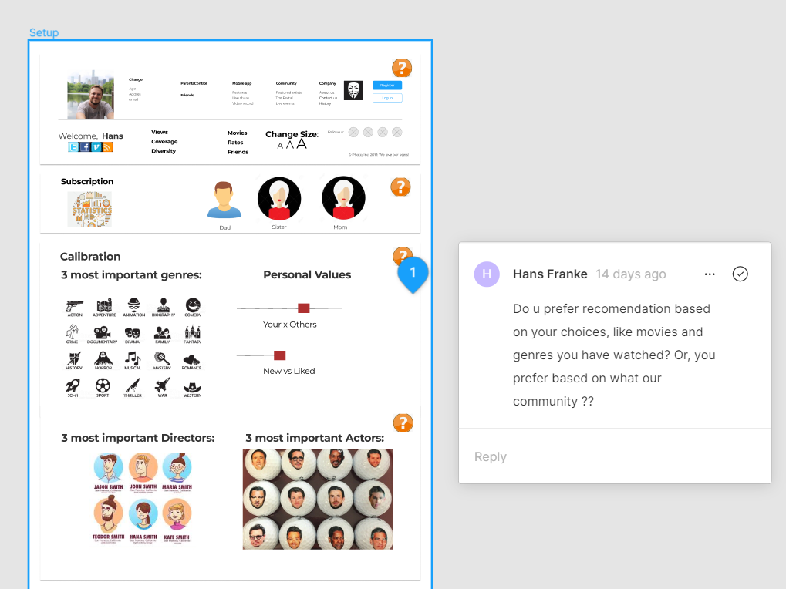

**Figure2**. Example on interface of user exerting control: he can select genres, directors and actors. Another form to exert control is rating a movie (explicitly), or for example simply watching a movie (implicitly).

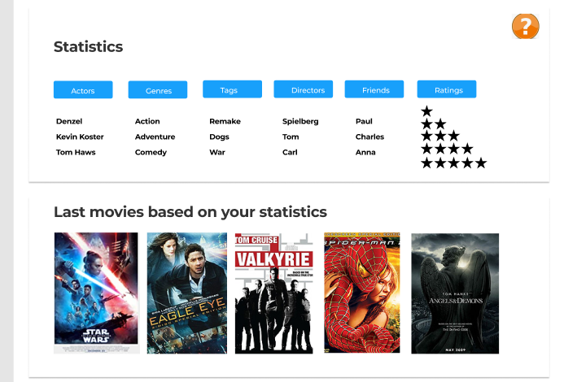

**Figure3**. User’s statistics to improve acceptance through transparent explanations, showing based on what preferences the last movies was recommended.

*Transparency* and *justify (*see figure 3, 4 and 5*)* were assessed but in an indirect way, with text showing to the user how the recommender was provided (i.e. based on movie you had watched or because of similar users watched), but not with high level detail (i.e what are the main similarities between users/movies). *Cold start* problem was answered in a login step with a user choosing 3 preferred genres (see figure2), but as our system is static no approach to a new movies was assessed.

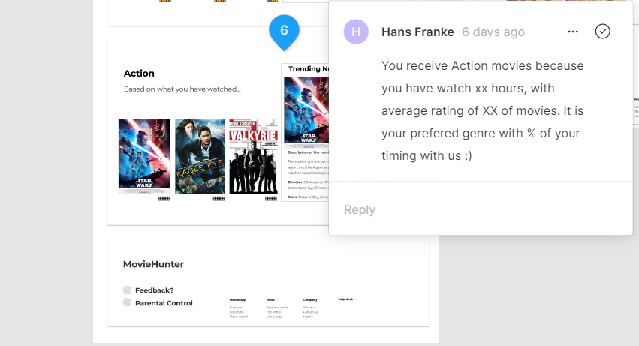

**Figure4**. Example of popup message to increase transparency and acceptance from the user.

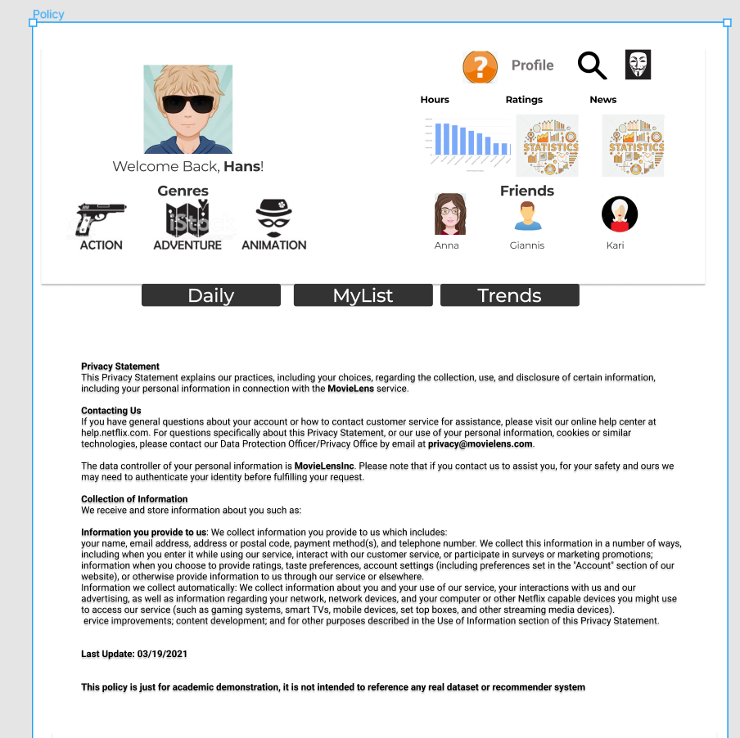

**Figure5**. Another example of transparency, on the policy page describe how the user data is collected.

*Diversity,* was assessed allowing user receive random recommendations that he never watched (see figure 6), it can be a new genre or a new movie unrelated to any similarity with movies or users. In the login screen the user can chose if they value most his previous experiences compare to others and if he likes most new content or liked content (i.e similar that what he has watched) (see figure2).

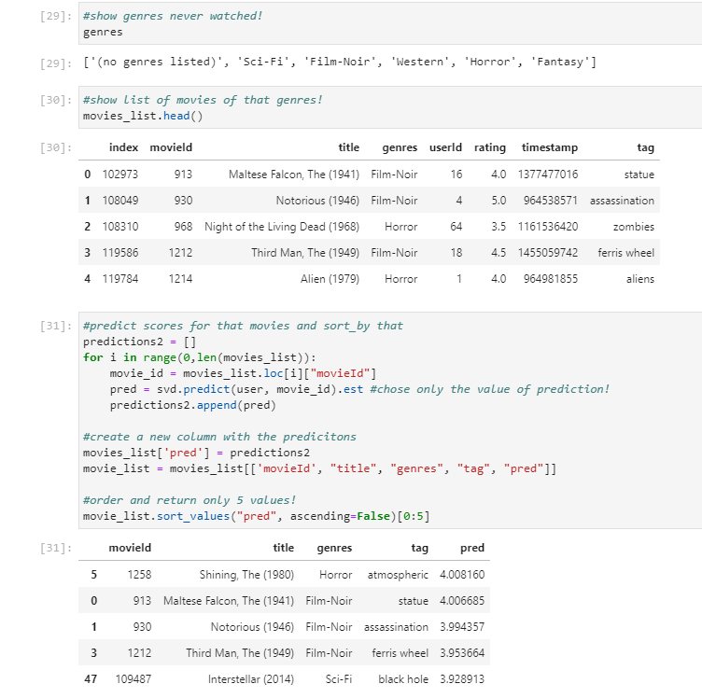

**Figure6**. Example of implementation of diversity, based on genres never watched by a user, and a print of the interface part of “Lucky wheel”. The prediction score was based on SVD(Single Value Decomposition).

A goal of the recommender is increase audience metrics. Crafting content that connects with its preferred audience requires understanding audience objectives and how these objectives match enterprise goals. Starting by aligning with your audience personas, use trend data to trace the lifecycle of a customer and their content needs.

## 3.2 Metrics

On the other side of the interface there is a company that need some metrics to measure the success of the recommender, not only based on users perspective but in business as well. For example, **users** **metrics**: diversity, engagement and satisfaction.

So to address **users values** the metrics would be, % of filters selection (i.e genres, tags, friends) this will measure how much **control** a user has over the recommender**. Diversity,** can be measure with how many %random chances the user is trying in the lucky wheel. **Engagement**, can measure by how many suggestion to friends a user made, or how many days/week a user join the website. **Satisfaction** can be measure by how many positive or negative feedbacks a user made, or number of friends invited.

**Business metrics** can be views hours, % of correct prediction (accuracy), coverage (how many genres a user has watched or % long tail movies), number of subscriptions. These metrics is not only for make more money, but they are important to measure if the user has his own metrics/values fulfilled, like a user that is increasing his average number of views probably has his values addressed.

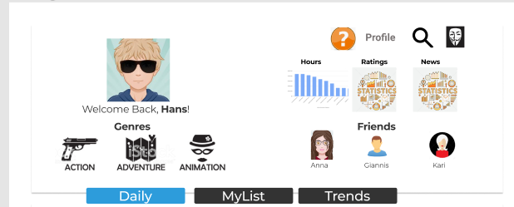

**Figure7**. On the main interface the is a quick overview of views (measured in hours) to show in a transparent way to the user his engagement to the website.

## 3.3 Explanation of algorithms:

### 3.3.a. Simpler Recommender

One simple way to recommend a movie is based on ratings. One can use weighted ratings based on rates and number of votes (i.e. score). It can be built on “best” movies, genres, tags, and many different filters. Who never go to google and typed: “best movies of all time?”, and the return is a list from **imbd** showing their famous TOP250 [ <https://www.imdb.com/chart/top/> ].

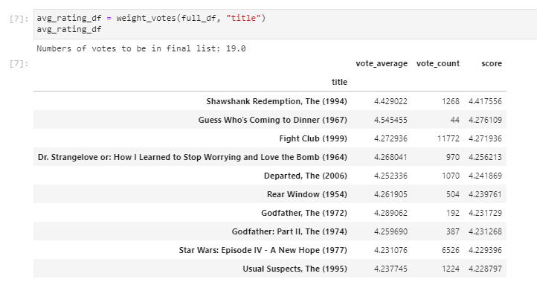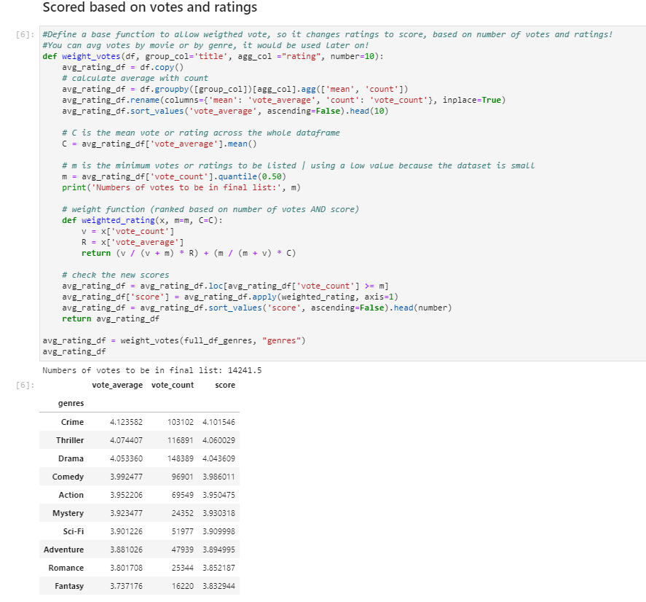

**Figure7**. Example of simple recommender based on weighted voting/rating, of genres and movies.

### 3.3.b. Content Based Recommender

The recommender we built in the previous section suffers some severe limitations. For one, it gives the same recommendation to everyone, regardless of the user's personal taste. If a person who loves romantic movies (and hates action) were to look at our Top 10 Chart, he wouldn't probably like most of the movies. If he were to go one step further and look at our charts by genre, he wouldn't still be getting the best recommendations.

To personalize our recommendations more, an engine that computes similarity between movies based on certain metrics (i.e tags, genres, users views) and suggests movies that are most similar to a particular movie that a user liked. Since we will be using movie metadata (or content) to build this engine, this also known as **Content Based Filtering. The user can provide input to this part choosing in the interface his preferences.**

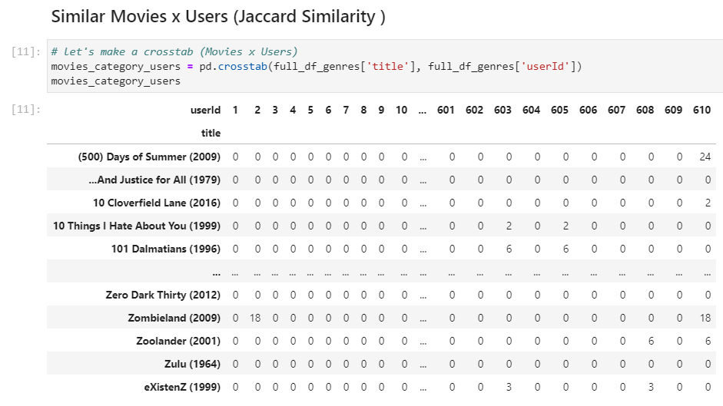 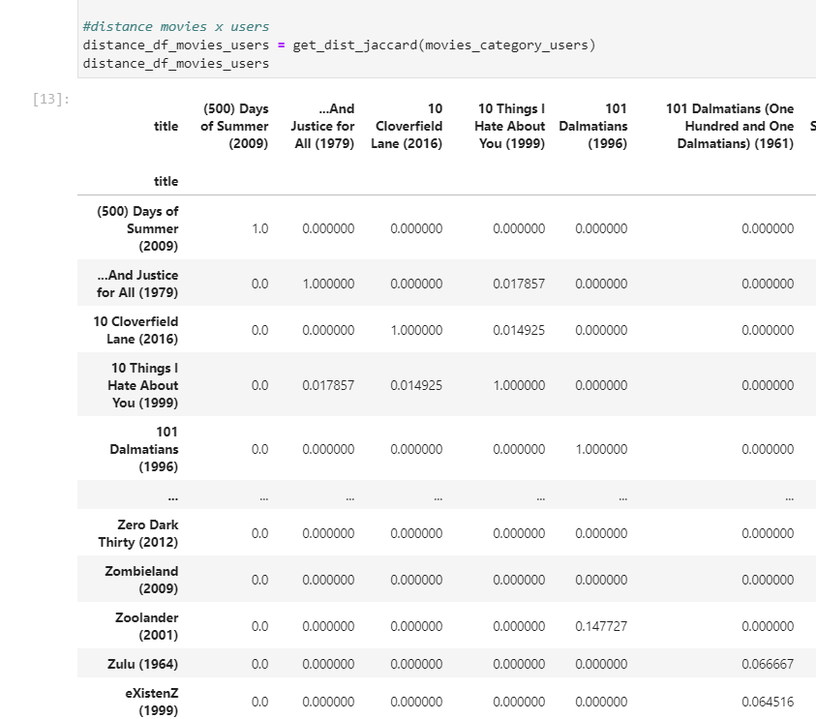 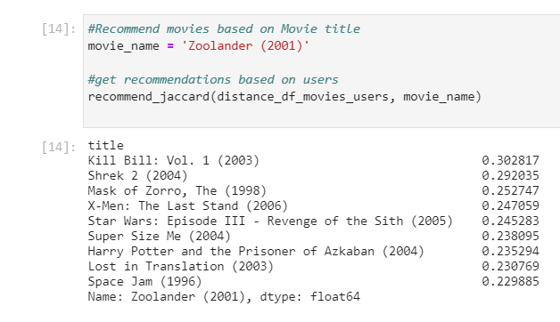

**Figure8**. Example of similarities using jaccard distances, on the left is similatiries from movies to users (which user watch that movies), center is distance from movie to movie based on users rates, and right part is recommend a movies based on “Zoolander”, order by the similarities.

### 3.3.c. Collaborative Filtering

Content based engine do not close all the gap, for it is only capable of suggesting movies which are close to a certain movie. That is, it is not capable of capturing **tastes** (i.e users preferences) and providing recommendations across genres. Also, the engine that we built is not really personal in that it doesn't capture the personal tastes and biases of a user. Anyone querying our engine for recommendations based on a movie will receive the same recommendations for that movie, regardless of who he is. Therefore, a technique called **Collaborative Filtering** is based on the idea that users similar to me can be used to predict how much one will like a particular product or service those users have used/experienced but one have not. Another, advantage of collaborative filtering is that it generates models that help users discover new interests.

In this work was used the **Surprise** library that used extremely powerful algorithms like **Singular Value Decomposition (SVD)** to minimize RMSE (Root Mean Square Error) and give great recommendations. The algorithm was improved with *gridSearch* (selection of the best parameters and errors metrics).

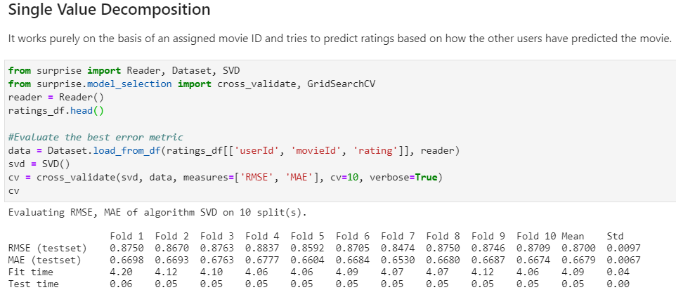 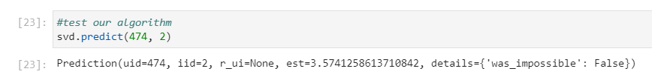

**Figure9**. Example of SVD: left is the training process and evaluating the error metrics (87% accuracy within RMSE), right is the prediction of user 474 rates movieId 2 with 3.57.

### 3.3.d. Hybrid Recommendation

Merging the 3 previous approaches in one single recommendation is the best scenario to take in account different criteria to fully satisfy a user. For example, we can start by assessing similarities based on others users (collaborative filter), then search the movies within the 10 most similar users (content based), filtering for the 3 target_user preferred genre (content based as well), ranking the movies by others users score (basic filter, weighted ratings). The final list of movies is the input for the SVD to predict based on that list which movies will have the most chance to assess the target user preferences.

Using this techniques we are assessing the users values (user can change parameters of the algorithm explained on the interface and Methodology chapter), and assessing the metrics of the recommender like: user engagement, increasing views, and one of the most important: user satisfaction because we are increasing the chance to predict correctly. For example, one can filter which friend he/she want to compare, select genres that want to include, the level of similarities (own x others), and provide feedback in each iteration (i.e accept or refuse the recommendations).

|  |  |
| --- | --- |
|  |  |
|  |  |

**Figure10**. Example of hybrid recommender: First, select similar users based on distances to movies (jaccard), then filter user top 3 genres (content based, based on voting score), after filter this dataframe within similar users and preferred genres and finally use SVD to predict all movies and sort the list based on prediction scores.

# Conclusion

In this work, was designed an interface using library patterns to asses **values**, allowing user **control** over the recommender. The interface is crucial, for it is the connection point from end-user to the recommender, through her that you are explaining to your users how you are building the recommendations (transparency and acceptance) and take his own **preferences** into account for future recommendations (improve your future recommendations).

This strategy makes the user more relevant requiring inputs and context to a recommender, for example, providing feedback that will be used to better predicting in the future. This is given, allowing user exert control over the algorithm, choosing his preferences (genres, actors, tags). A teenager may be interested in more trend topics similar to his friend, but an adult on the other side may be interested in old well rated movies of western genre. Using the interface the user can select parameters and visually notice how it changes his recommendations.

The work assessed metrics of **users** and **business**, trying to taking in account inevitable tensions like: more views or more diversity? Metrics sometimes contrary to each other, but the tension was minimized through transparency improving user acceptance and in a natural way increasing views because the algorithm would make better predictions, once it used users inputs and control.

# Bibliography

|  |  |
| --- | --- |
| [1] | T. Asikis, J. Klinglmayr, D. Helbing and E. Pournaras, "How value-sensitive desing can empower sustainable consumption," no. https://doi.org/10.1098/rsos.201418, 2021. |
| [2] | R. Burke, "Evaluating the dynamic properties of recommendation algorithms.," *In Proceedings of fourth ACM conference on recommender systems,* no. doi: 10.1145/1864708.1864753, 2010. |
| [3] | R. Burke, "Hybrid recommender systems: Survey and experiments. User Modeling and User Adapted Interaction," 2002. |
| [4] | M. J. Pazzani and D. Billsus, "Content-based recommendation systems," no. http://www.springerlink.com/index/qq35wt68l6774261, 2007. |
| [5] | S. Ternier, K. Verbert, G. Parra, B. Vandeputte, J. Klerkx, E. Duval and X. Ochoa, "The ariadne infrastructure for managing and storing metadata.," *IEEE Internet Computing, 13 ,* no. doi: 10.1109/MIC.2009.90, p. 18–25, 2009. |
| [6] | R. Hu and P. Pu, "Helping users perceive recommendation diversity.," *In Proceedings of the workshop on novelty and diversity in recommender systems, divers.,* 2011. |
| [7] | "Pattern Library," no. https://aapatternlibrary.wordpress.com/. |
| [8] | D. P. ,. V. Chen He, "Interactive recommender systems: A survey of the state of the art and future research challenges and opportunities," 2016. |
| [9] | Z. Fayyaz, M. Ebrahimian, D. Nawara, A. Ibrahim and R. Kashef, "Recommendation Systems: Algorithms, Challenges, Metrics, and Business Opportunities," 2020. |
| [10] | H. Cramer, J. G. Gathright, A. Springer and S. Reddy, "Assessing and addressing algorithmic bias in practice," *https://doi.org/10.1145/3278156,* 2018. |
| [11] | J. Davis and L. Nathan, Value Sensitive Design: Applications, Adaptations, and Critiques, 2015. |
| [12] | R. Dobbe , S. Dean, T. Gilbert and N. Kohli, "A Broader View on Bias in Automated Decision-Making: Reflecting on Epistemology and Dynamics," no. https://doi.org/10.14763/2020.4.1534, 2018. |
| [13] | B. Friedman, Human Values and the Design of Computer Technology, Cambridge University Press, 1997. |
| [14] | S. Kheirandish, M. Funk, S. Wensveen, M. Verkerk and M. Rauterberg, "HuValue: a tool to support design students in considering human values in their design," *International Journal of Technology and Design Education,* no. https://doi.org/10.1007/s10798-019-09527-3, p. 30:101, 2020. |
| [15] | J. Simon, P.-H. Wong and G. Rieder, "Algorithmic bias and the Value Sensitive Design approach," 2020. |
| [16] | StakeholderMap, "https://www.stakeholdermap.com/retail-stakeholders.html". |

# Appendix:

## Code

The is provided in a jupyter notebook named: Media_RecommenderBackEnd_HansFranke.ipynb

Open in Github:

<https://github.com/hansfranke1985/Public-Media/blob/main/Assigment_2/Media_RecommenderBackEnd_HansFranke.ipynb>

Or you can open the html generated:



## Interface

The interface is public available at: <https://www.figma.com/file/ItyHCF6CAdeDkbazTYkyAI/Media?node-id=23%3A83>

**Sign and login pages:**

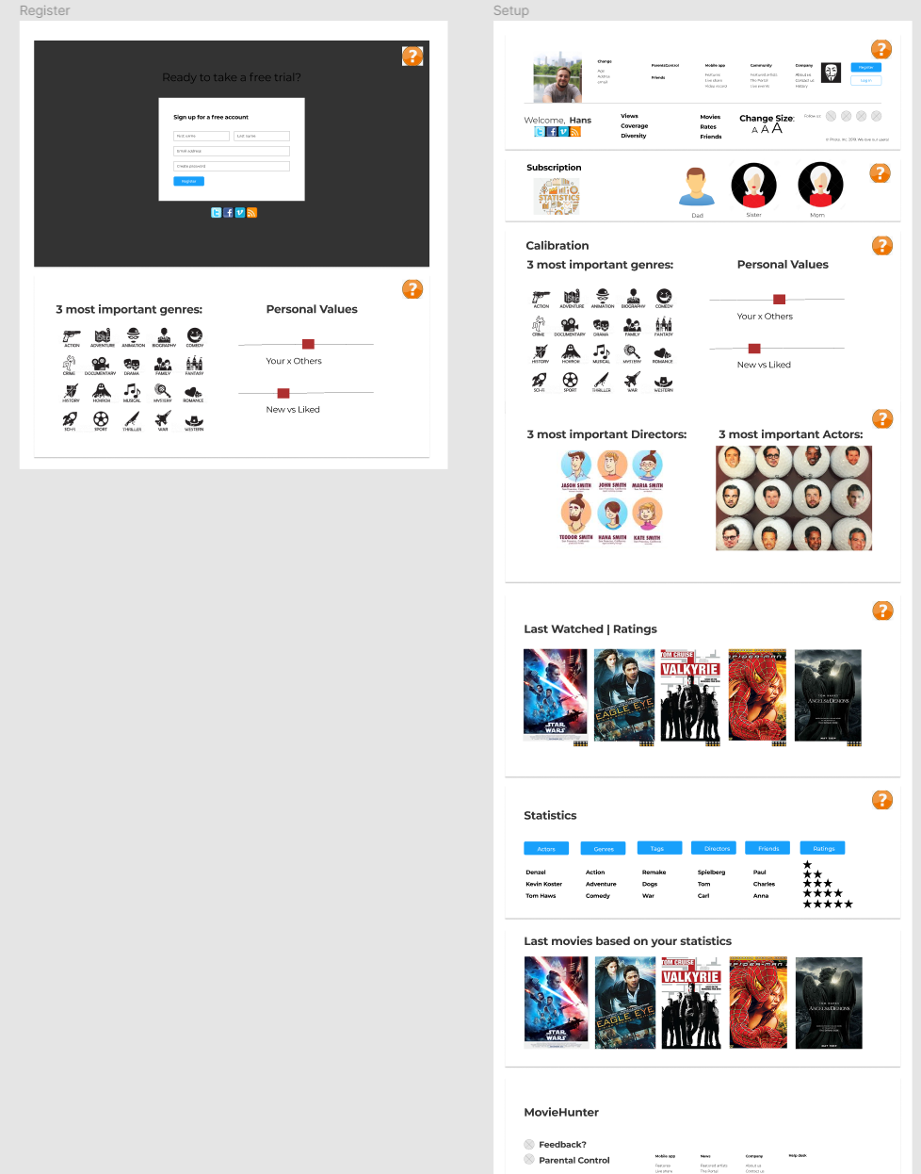

**Main Page and MainPage/MyList:**

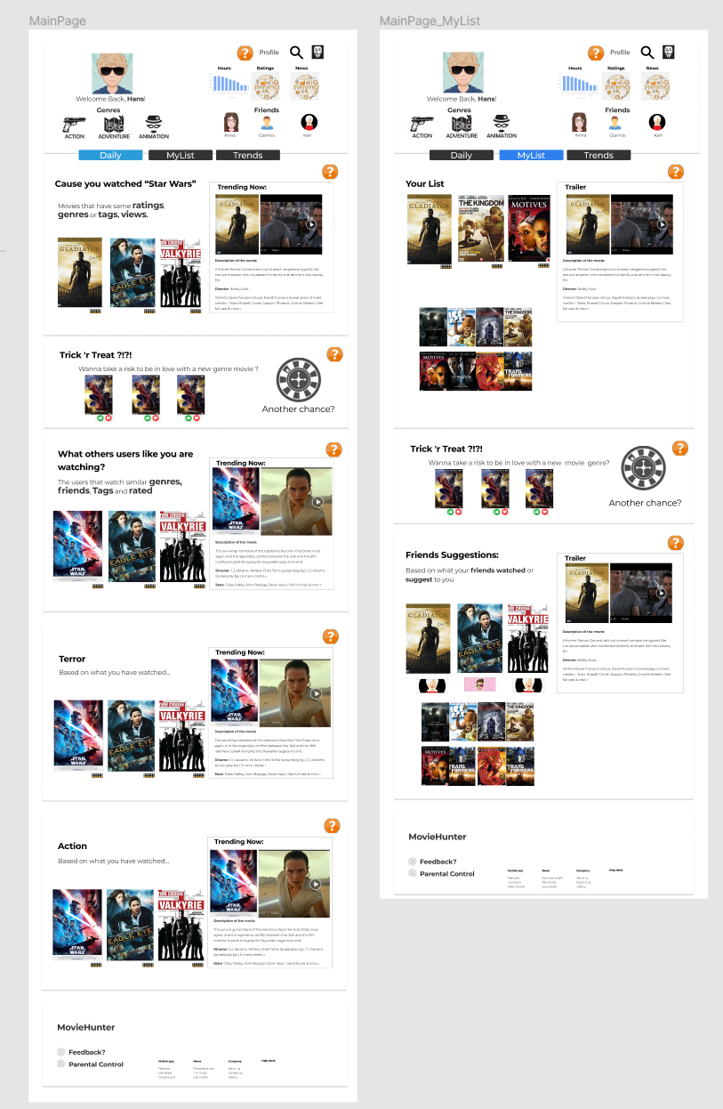

**Search Page:**

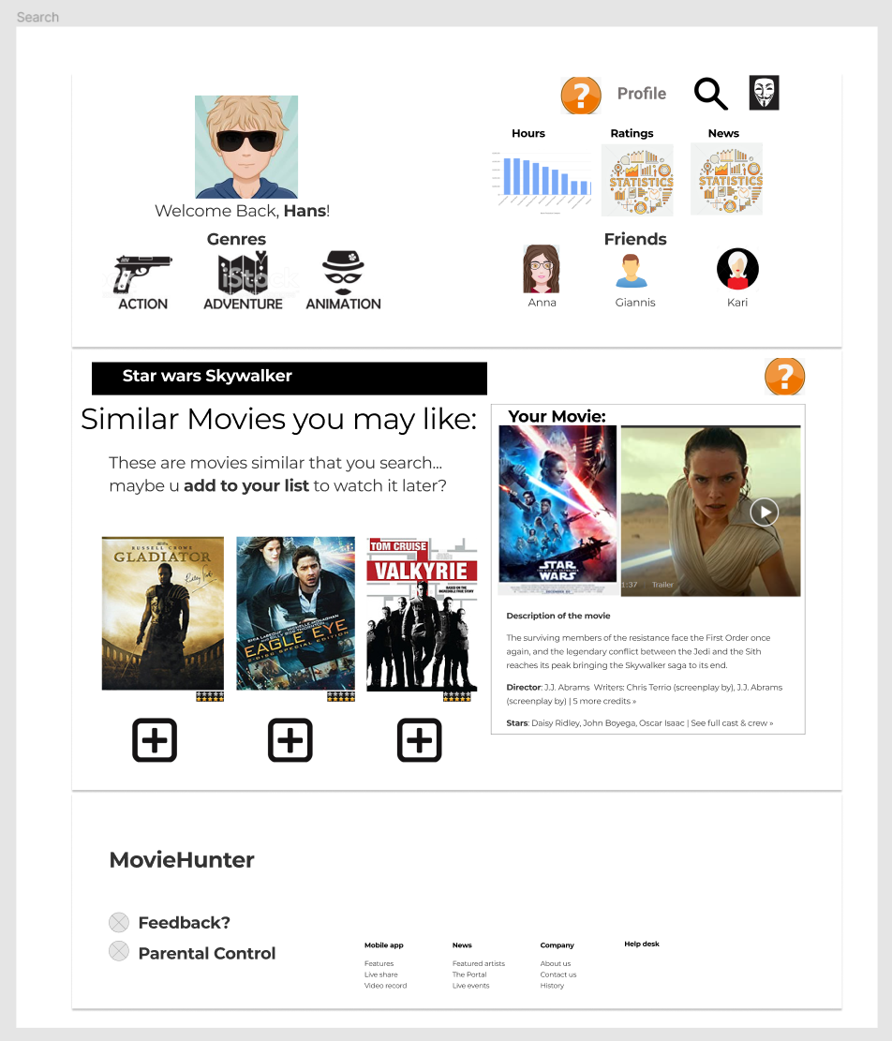

**Policy Page:**

